

UNIVERSITY OF SYDNEY

**INFO2222**

Usability and Security

**Full LOGBOOK**

**of**

**Project Brief**

SID: 490441372

April 16th, 2021

**March 12th, 2021 - WK2 Logbook**

**PERSONAs for web**

The sample persona based on our **team’s** thoughts.

|  |  |
| --- | --- |
| **Attribute** | **Value** |
| Name | Jasmine Valdez (she/her) |
| Age | 20 (Second Year) |
| Gender | Female |
| Background | Grew up in the Blue Mountains |
| Reason for choosing USYD | * Likes the degree structure and offerings (Advanced Computing) |
| Likes about USYD | * Campus |
| Dislikes about USYD | * Poorly / administered managed units |
| Opinions on USYD systems | * Edstem   + Likes messaging and forum system   + Likes design   + Dislikes notification structure * Canvas   + Dislikes its calendar system   + Dislikes reminder system   + Likes info of courses   + Likes layout of navigation and menus * Sydney Student: Mucky, hate it * Dislikes email notification systems |
| Program of study | Advanced Computing (Computer Science, Finance) |
| Favourite unit of study | INFO1113 |
| Personal challenges | Shy / lack of confidence |
| Career goal | Mega Tech company / investment corporation |
| Plans after graduation | Full-time work |

**PACT analysis of project space (collaborate with team)**

*People use technologies to undertake activities in contexts*

People

* Students from The University of Sydney
* Website admin(s)

Technologies

* Access to the Internet
* Input the keyword about the part of web development what they want
* View the tutorial material about what they want to learn
* Material came from the web-development-related courses from University

Activities

* Learn the basic skill of website development
* Discuss and solve problems with other developers

Contexts

* Related to web development skills and knowledge

**GROUP MEETING NOTES**

First of all, we introduced ourselves at the beginning in order to form a group better.

Then we wrote our checklist according to project brief. What we need to do this week is Task1 and Task2 in project brief, so we analyze this.

1. We need to find the needs and characteristics of our users.

2. We need consider what functions can our website provide to users.

3. We also drafted the team contract and everyone signed it.

Finally we planned what we needed to do at the next meeting.

**Source codes: routing to different pages**

from bottle import template, run, route

@route('/')

@route('/hello/<name>')

def greet(name = 'Stranger'):

return template('Hello {{name}}, <b>how are you?<b>', name = name)

run(host = 'localhost', port = 8080, debug = True)

**Source codes to create SYNCs 'About Us' page**

from bottle import static_file, run, route

@route('/assets/<filename:path>')

def send_static(filename):

print(filename)

return static_file(filename, root='./SUITS/assets/')

@route('/assets_sync/<filename:path>')

def send_static(filename):

print(filename)

return static_file(filename, root='./SYNCS/assets/')

@route('/')

@route('/module1/syncs')

def syncs():

return static_file("About Us - SYNCS.html", root = './SYNCS/')

@route('/module1/suits')

def suits():

return static_file("About Us - SUITS.html", root = './SUITS/')

run(host = 'localhost', port = 8080, debug = True)

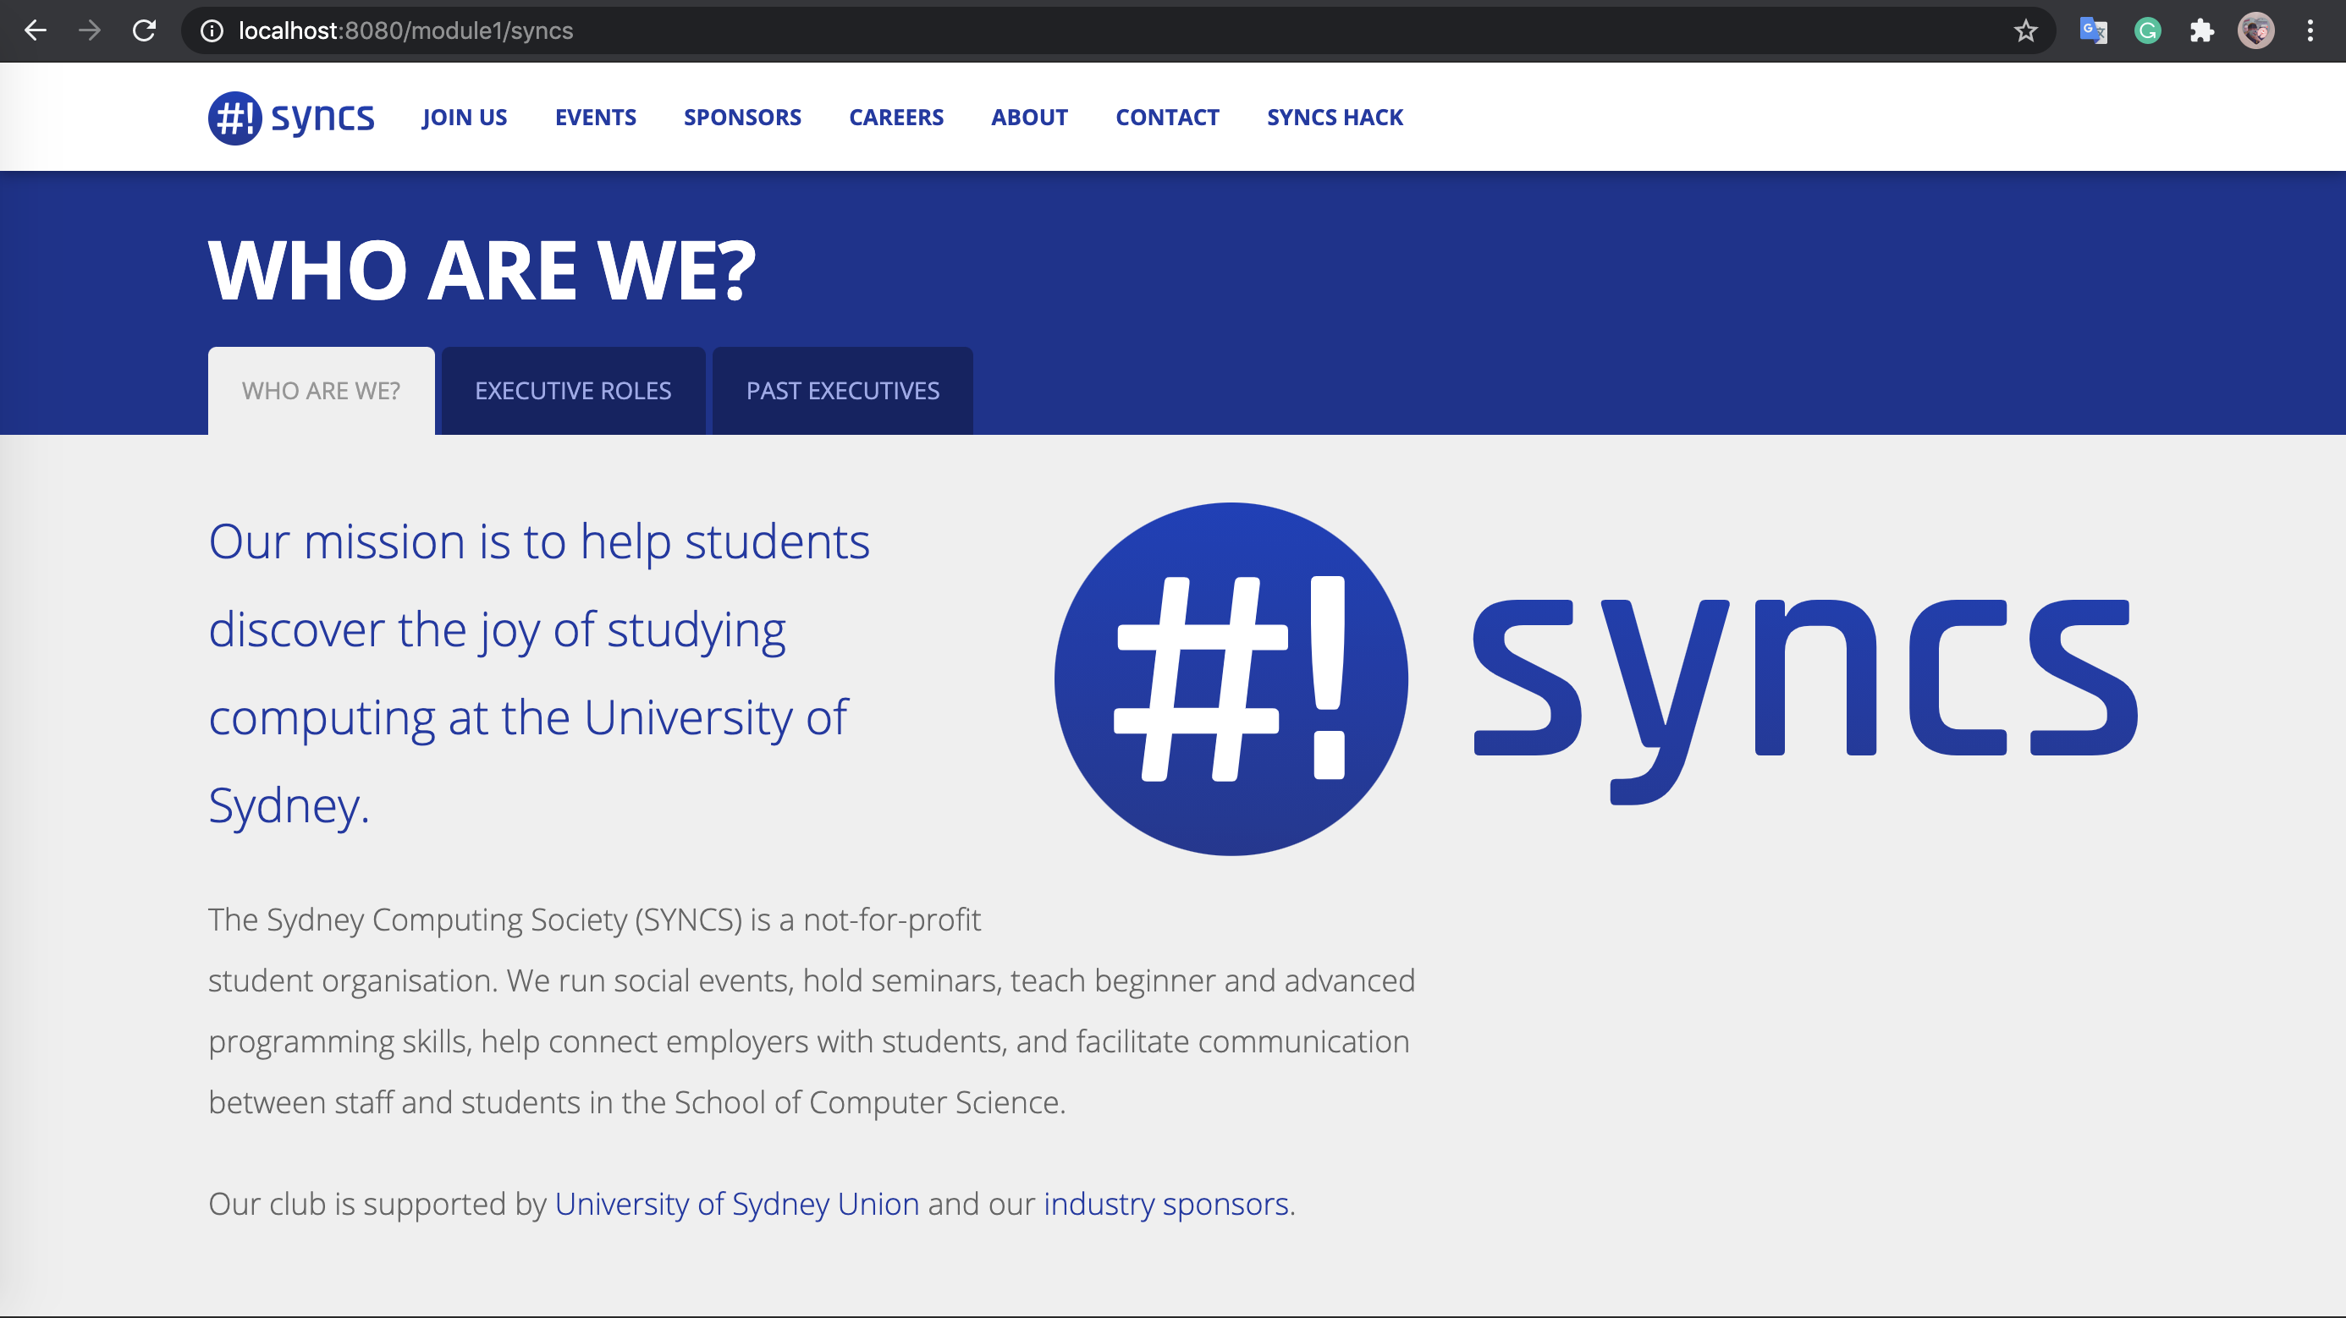

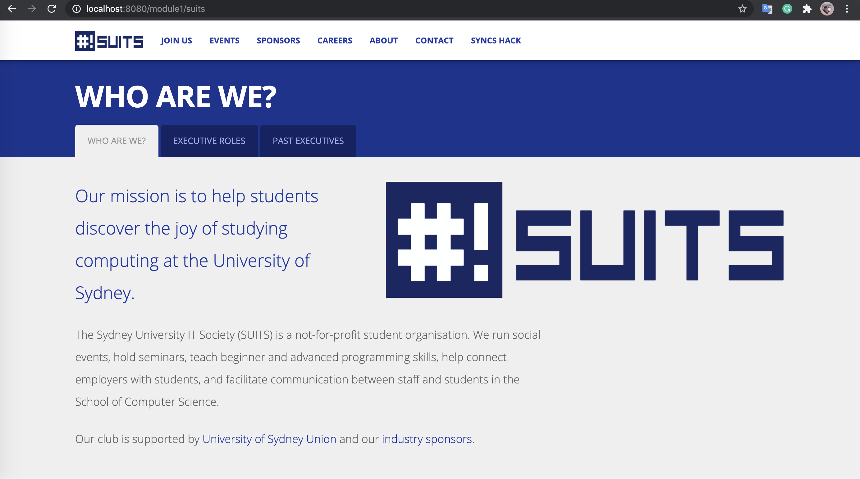

**SYNCs page accessible through routes about/suits and about/syncs**

**(You can download html code in github, if you want see code about creating)**

**First reflection:**

For this week task, I spent a lot of time on write the code about creating the ‘about us’ page and route to different pages, because I never learn something about web development before. I need pay more attention on it in order that I can improve my skills about web development. I found that persona and template are useful. They can reduce some workload and focus on the users’ needs.

**March 25th, 2021 – WK4 Logbook**

**Sitemap of FAQs**

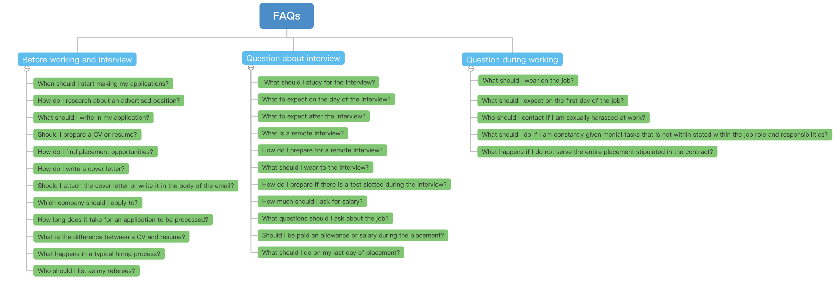

**GROUP MEETING NOTES**

After two more weeks' running-in, our team started to work formally. This time, we mainly carried out Task 3,4,5 in Project Brief. We also discussed Survey Building and Web Ideas. Each team member contributed constructive ideas and analysis about our web page.

For Task 3, three team members discussed the design of web page and drafted the wireframe to select the final version of the wireframe.

For Task 4, two team members including me conducted card sorting for our website and invite some people to do the card sorting in order that we can handle what the users want.

For Task 5, we firstly divided our wireframe into five parts and assign them to each member. And we also learn how to prototype the website by Figma and make our prototype.

Finally, we also discussed the Web page content, and each team member provided effective opinions about their own website content.

**Observation for Usability Testing Session**

Facilitator: Kaijun Peng

Participant: Rick

1. Book a desk in fisher in any time

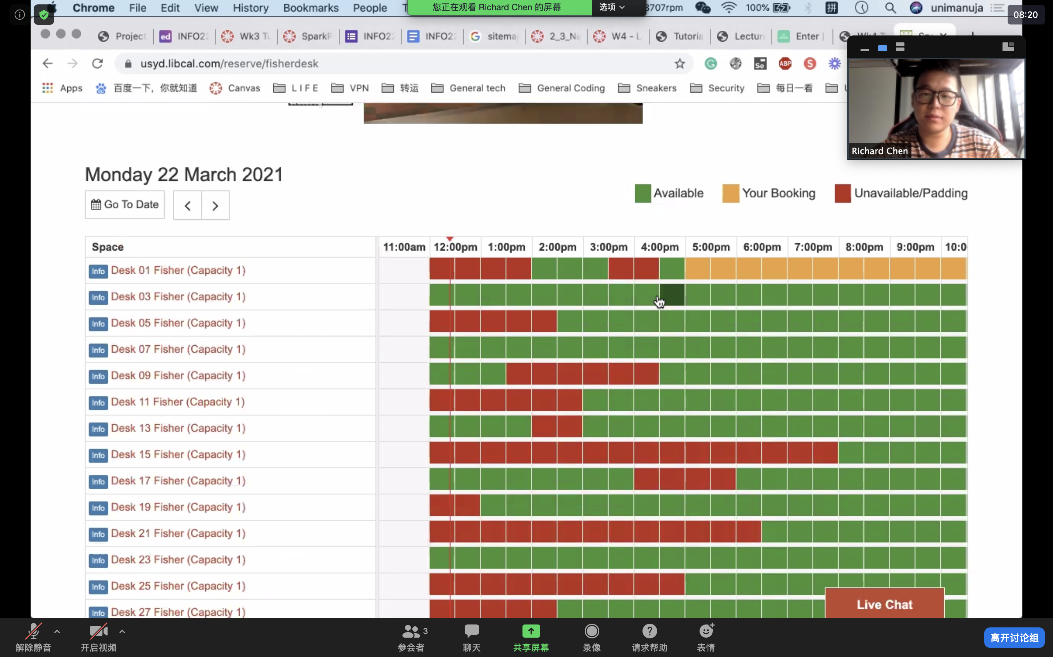

1. Identify the opening hours for SciTech Library on Easter Monday.

– Search when is easter Monday 5 April, it is closed on that day. takes 20s to complete

1. When is the next Introduction to EndNote training session held?

– Go to study page, “Online Training”.

It is easy to find the page, but hard to find when is next one. – back to the home page and go to study page again, go to referencing, it shows the same page again. Then go to the FAQs to find when is the next one, but there still is no any information about that. Go to the “Online Training page” and “Workshop”

Rick: There is a clear structure to find any information.

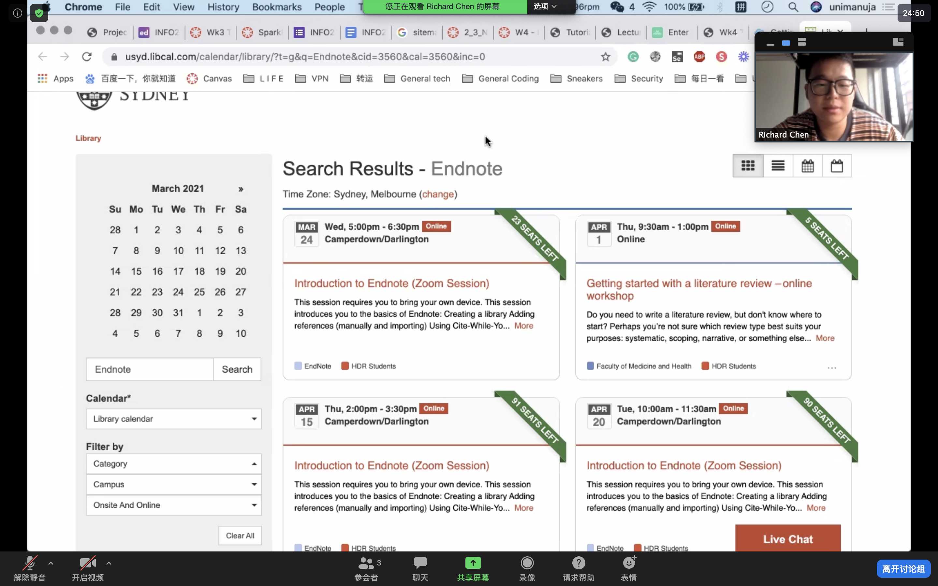

There are two tutorial questions here and they are completed in different time duration. The factor influenced the time could web structure, facilitator’s guidance and participant’s habit that use website.

**Content and Prototype of own wireframe design**

<https://img.88icon.com/download/jpg/20200817/33a654a28cf7125a6f0d2b6fbf537087_512_512.jpg!88con> for profile pic sample

<https://remixicon.com/> for all icons in the prototype

<https://www.figma.com/file/kGGsAbVb0wZedLg0xFdysC/info2222_RE3_Group4-colors?node-id=149%3A46> for prototype web tools

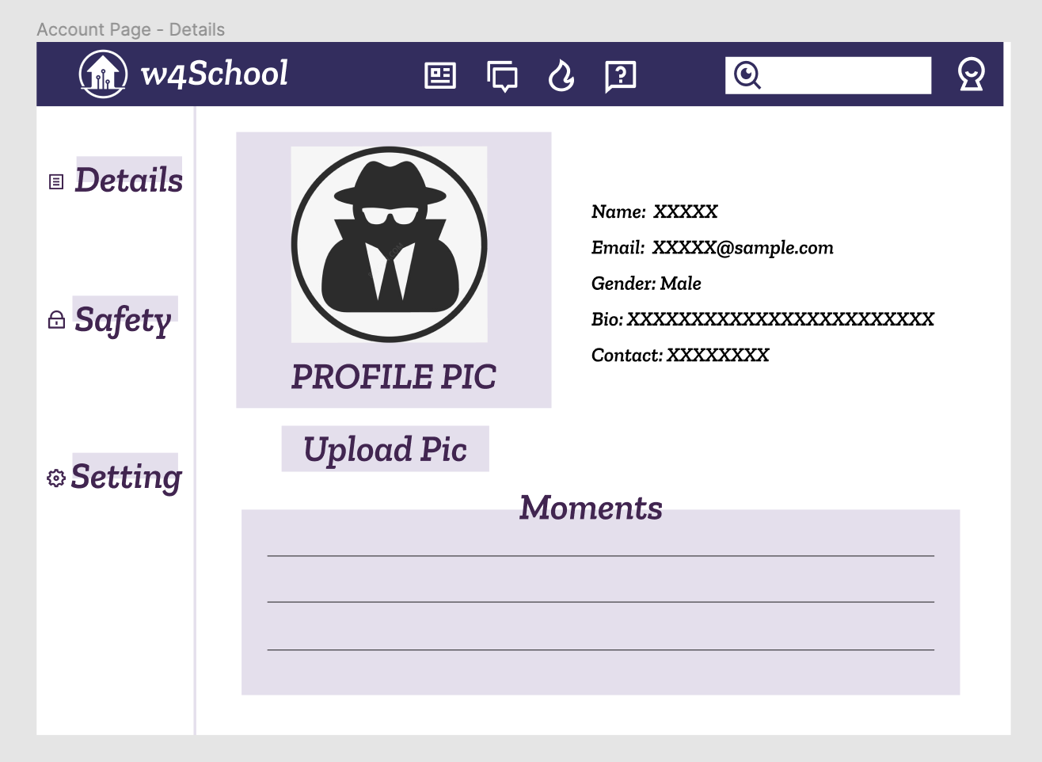

**Prototype for my own design for account page**

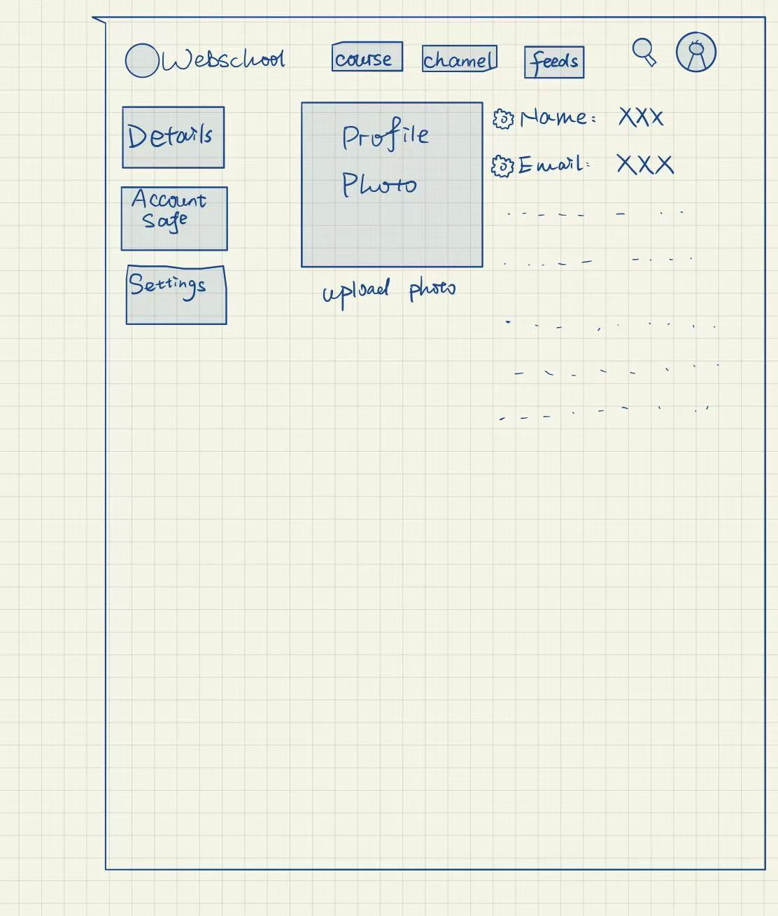

**Sketch of my own design for account page**

**Notes on evaluation done on own designs**: At the beginning, I just do the sketch for my own design with raw outline. When I do the prototyping I found that there are something should be improved, such as the layout of page and more elements should be added into page.

**Source codes: basic login page**

from bottle import get, run, route, request

@route('/login')

def login():

return '''<form action="/login" method="post">

Username: <input name="username" type="text" />

Password: <input name="password" type="password" />

<input value="Login" type="submit" />

</form>'''

def check_login(username,password):

if username == 'admin' and password == '123':

return True

else:

return False

@route('/login',method='POST')

def do_login():

username = request.forms.get('username')

password = request.forms.get('password')

if check_login(username,password):

return '<p>Your login information was correct</p>'

else:

return "<p>Login failed.</p>"

run(host='localhost',port=8080)

**Source codes:** **to-do list**

The source code references from: <https://bottlepy.org/docs/dev/tutorial_app.html>

The origin code has been uploaded GitHub already.

After reading this tutorial, I learned to use Bottle to create a project, such as routing, using the Bottle template capability to format output and handle GET/POST parameters.

**Source codes:** **add new web page**

def contact():

'''

login_form

Returns the view for the login_form

'''

return page_view("contact")

add new function contact to form page in controller.py

@get('/contact')

def get_contact():

'''

get_contact

Serves the contact page

'''

return model.contact()

add new function contact to form page in model.py

<table border="1">

<tr>

<td>0412345678</td>

<td>example@gmail.com</td>

</tr>

</table>

add new html for contact to form page in template

**Ideas for card sorting session (TEAMWORK)**

Out team divided our sort into two parts, one of them is our website-function-oriented card sorting, the another one is the card sorting about the programming knowledge.

The programming knowledge part achieved 100% agreement about the card sorting. The specified knowledge about HTML, Python Bottle, CSS and JavaScript will be assigned to HTML module, Python Bottle module, CSS module and JavaScript module respectively.

According to the result from website-function-oriented card sorting, this provide a clear idea about our website's design architecture on different page. Most of user agree the idea we are thinking for. 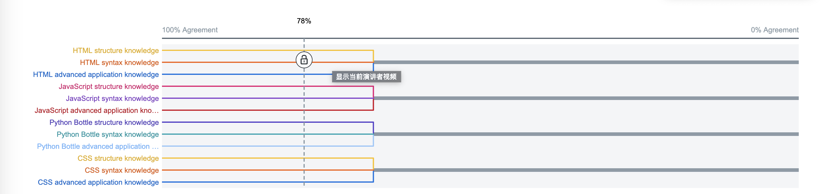

**Result from Card sorting in Optimal Workshop(**[**https://www.optimalworkshop.com/**](https://www.optimalworkshop.com/)**)**

**Second reflection:**

For these two weeks, I completed some tasks for our project and finished the tutorial sheet on time. But during the process, I found tons of things needed to be improved.

For week 3, I mainly focus on the wireframe design and card sorting for our project. When I do the drafting of wireframe, I suddenly realized that I need to have a better understanding of our project in order that I can do better for our project. And the card sorting actually improved my skills about brainstorming, whatever the open card sorting or closed one, they need a good idea to figure out.

For week 4, I mainly focus on the prototyping web design and searching for contents. Prototyping is a fresh and unfamiliar thing for me actually, I spent a lot of time to know how to do and what should I do, including learn how to use Figma to collaborate with team members to prototype our project. Also, I found that the searching content is not a so-called easy thing to do, it needed me to have a clear direction to do instead of searching randomly, which can improve the efficiency.

**April 8th, 2021 – Sem Break Logbook**

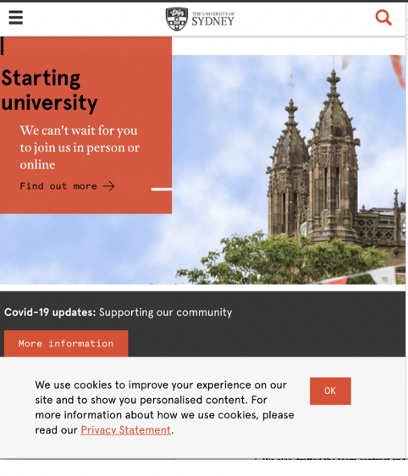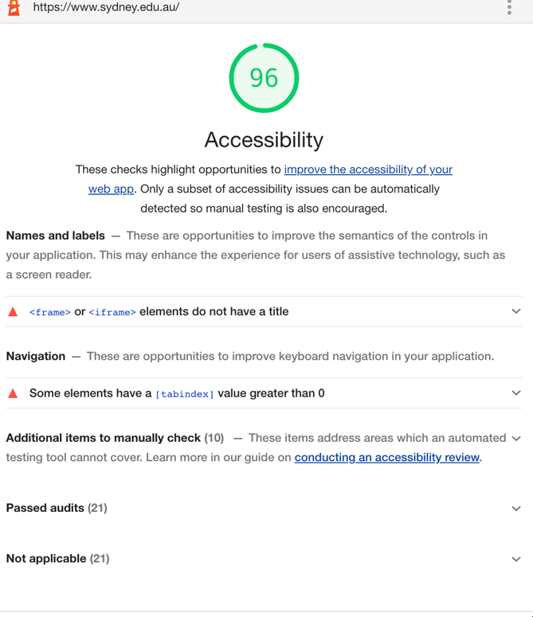**Accessibility Reports**

**Steps taken to generate the results for USYD:**

The manual check steps that been followed is Easy Checks from WAI and assisted by Web Developer Extension of Chrome. The automated auditing tool is Google Lighthouse. Lighthouse grade the accessibility of the Sydney University page 96/100.

**Lighthouse Test:**

Overall, the accessibility of sydney.edu.au is almost perfect. There are two tiny problems, one is about names and labels and the other one is naviagtion. One video does not contain a title, it can be improved. And some elements hava a [tabindex] value greater than 0.

**Manual Test:**

**Page Title:**

The title that adequately and briefly describes the content of the page.

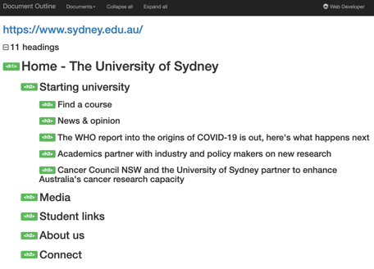**Image Alternatives:**

All elements have alternatives.

**Text:**

*Headings* – None is missing. (as shown right side)

*Contrasts* – It has a sufficient contrast ratio.

*Resize* – Well performace after resize the website.

**Interaction:**

*Keyboard access and visual focus* – Well performance in interaction.

*Forms, labels, and errors* - Well performance in interaction.

**General:**

*Moving, Flashing, or Blinking Content:*

Nothing automatically starts or lasts more than five seconds. Nothing will automatically update. No content flashes or blinks more than three times in one second.

*Multimedia (video, audio) alternatives:*

There is a video can be played after mouse-clicking, and can be access by keyboard. The video will not start automatically. But the video cannot access the captions, which means it cannot access the transcript.

*Basic Structure Check:*

After disabling all the image and CSS, the web still works, which means structure is well.

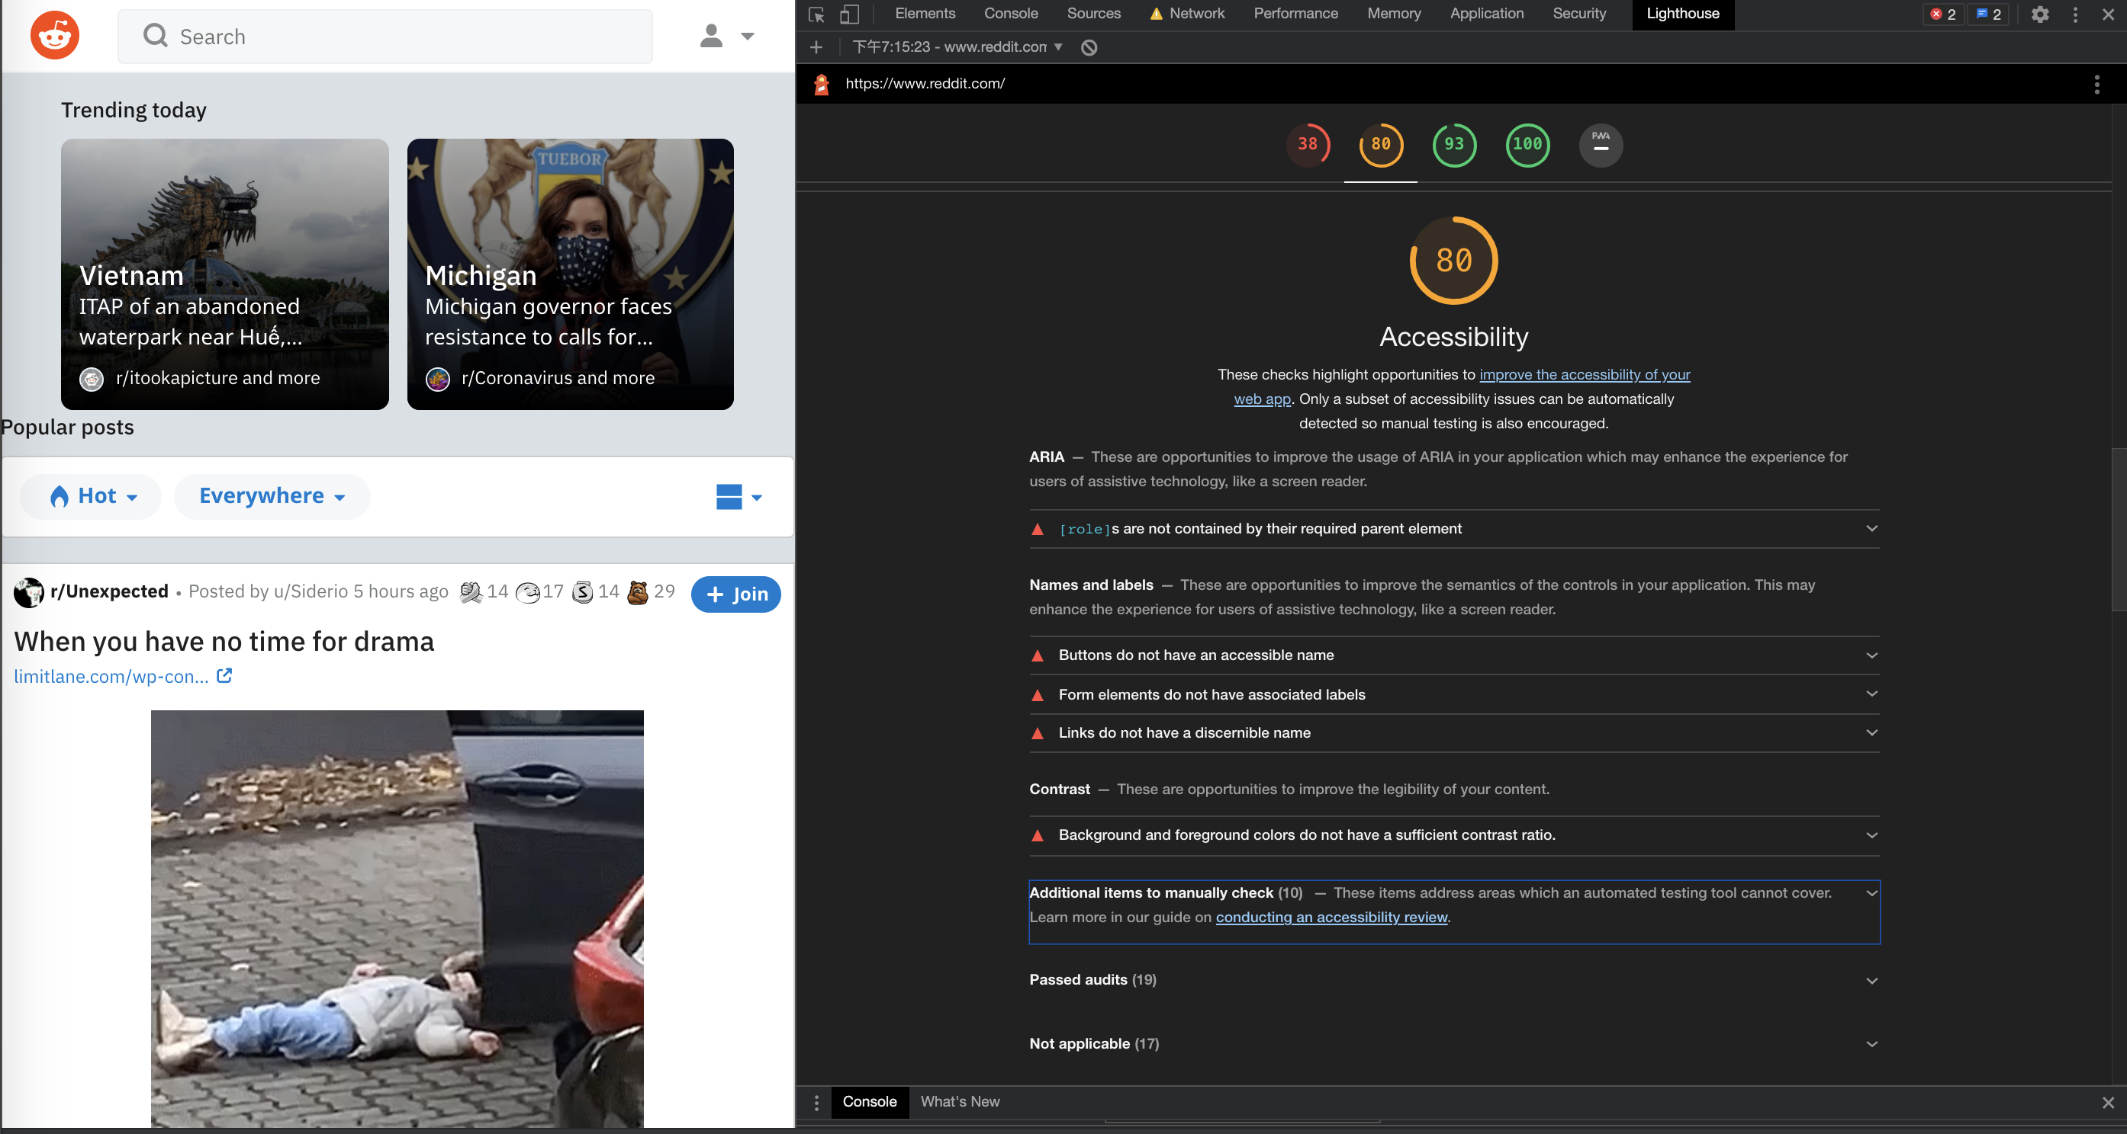

**Steps taken to generate the results for Reddit:**

The manual check steps that been followed is Easy Checks from WAI and assisted by Web Developer Extension of Chrome. The automated auditing tool is Google Lighthouse. Lighthouse grade the accessibility of the Reddit page 80/100.

**Lighthouse Test:**

Overall, the accessibility of reddit.com is great. There are several problems related ARIA, Names and labels and Contrast. For ARIA, [role]s are not contained by their required parent element. Some ARIA child roles must be contained by specific parent roles to properly perform their intended accessibility functions. For names and labels, buttons do not have an accessible name, form elemetns do not have associated labels and links do not have a discernible name. At last, for contrast, background and freground color do not have a sufficient contrast ratio.

**Manual Test:**

**Page Title:**

The title that adequately and briefly describes the content of the page.

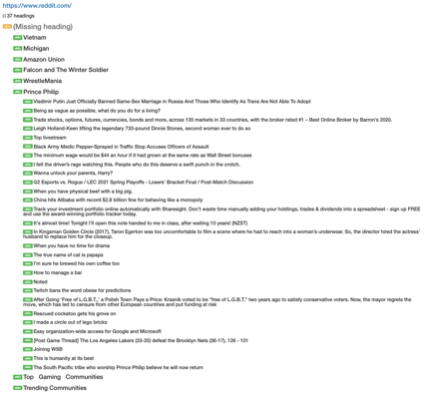**Image Alternatives:**

Most of elements have alternatives.

**Text:**

*Headings* – Heading<h1> is missing. (as shown right side)

*Contrasts* – background and freground color do not have a sufficient

contrast ratio.

*Resize* – Well performace after resize the website.

**Interaction:**

*Keyboard access and visual focus* – Well performance in interaction.

*Forms, labels, and errors* - Well performance in interaction.

**General:**

*Moving, Flashing, or Blinking Content:*

Nothing automatically starts or lasts more than five seconds. Nothing will automatically update. No content flashes or blinks more than three times in one second.

*Multimedia (video, audio) alternatives:*

If user scolls the page to the position where contains a video will automatically play and end after the duration of the video. But the media player cannot be accessed by the keyboard but can be done with mouse. User also can change the volume. But there is no any caption or audio description.

*Basic Structure Check:*

After disabling all the image and CSS, the image is still showing, the reason is not detected. But the main function still works, the web structure is basically well except the content follwed by video also cannot be shown.

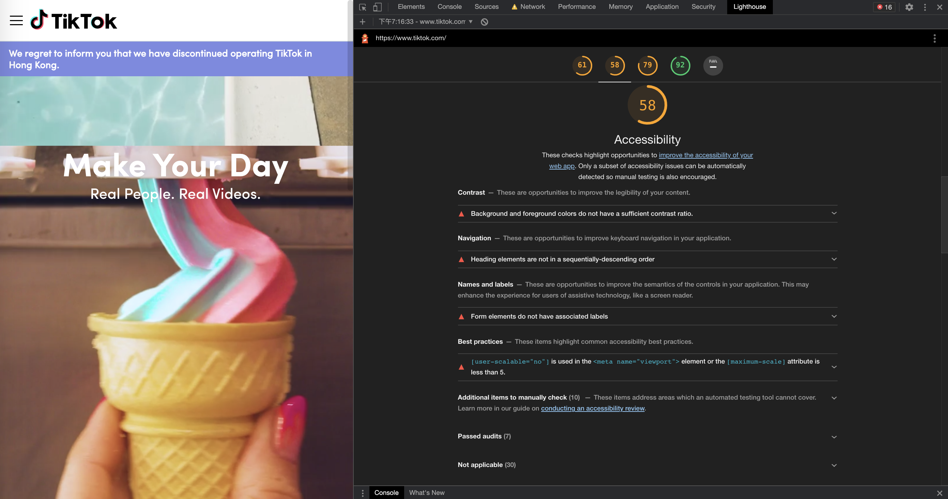

**Steps taken to generate the results for Tiktok:**

The manual check steps that been followed is Easy Checks from WAI and assisted by Web Developer Extension of Chrome. The automated auditing tool is Google Lighthouse. Lighthouse grade the accessibility of the Tiktok page 58/100.

**Lighthouse Test:**

Overall, the accessibility of tiktok.com is great. There are several problems related Contrast, Navigation, Names and Labels and Best practices. For contrast, background and foreground colors do not have a sufficient contrast ratio. For Navigation, Heading elements are not in a sequentially-descending order. Also for names and labels, form elmetns do not have associated labels. The aspect of best practices. [user-scalable="no"] is used in the <meta name="viewport"> element or the [maximum-scale] attribute is less than 5. Disabling zooming is problematic for users with low vision who rely on screen magnification to properly see the contents of a web page.

**Manual Test:**

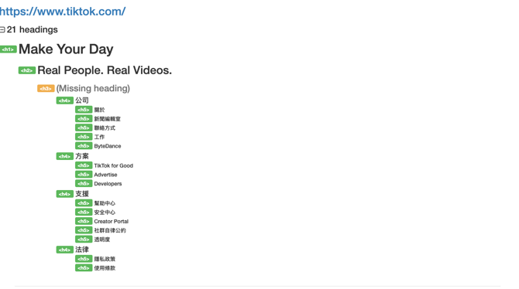**Page Title:**

The title that adequately and briefly describes the content of the page.

**Image Alternatives:**

All elements have alternatives.

**Text:**

*Headings* – Heading<h3> is missing. (as shown right side)

*Contrasts* – background and freground color do not have a sufficient

contrast ratio.

*Resize* – TikTok pages have text resizing issues. When the plain text is enlarged, the text on the page will fall off the button or overlap with other components.

**Interaction:**

*Keyboard access and visual focus* – Only accessible via mouse hovering.

*Forms, labels, and errors* - Well performance in interaction.

**General:**

*Moving, Flashing, or Blinking Content:*

Nothing automatically starts or lasts more than five seconds. Nothing will automatically update. No content flashes or blinks more than three times in one second.

*Multimedia (video, audio) alternatives:*

There is only one video, and it will automatically start but will not pause after three seconds and there is no way to pause the video.

*Basic Structure Check:*

After disabling all the image and CSS, then linearizing the page, the information on the page still makes senses. Headings are the information right above them that they apply to. Alternative text can convey information when images are disabled.

**Overall Discussion of the results:**

Human habits are always different. Automation tools can indeed easily and clearly show the accessibility, but they may not be able to completely recombine the use habits of human beings even after countless iterations.

**GROUP MEETING NOTES**

During these weeks including semester break, we held two meetings that all evaluate the design for our project. At the beginning of these two meetings, we discussed the evaluation idea from our mock users, and decided the direction of our evaluation. We split the idea to different parts and assign to each members. After meetings, so far, our project prototype have three iterative version, the first one is our raw prototype. And after the first user evaluation, we added more meaningful icon and alternative text. At last, we decided the final version of our prototype to demonstration.

**Evaluation Accessibility of own design**

In order that I can evaluate the accessibility from prototype, our group design a user test template to do the evaluation part. Below there are two participants to test our prototype of my part. (Others’ evaluation records also uploaded in group git repo)

**Participant 1**

**Name:** Encheng Qu

**Age:** 21

**Degree:** Bachelor of Software Engineering

**Gender:** Male (He/him)

|  |  |  |  |
| --- | --- | --- | --- |
|  | **Pages** | **User Response (Any issues?)** | **Additional Comments** |
| 1. | Sign up | None |  |
| 2. | Log in | None |  |
| 3. | View Bottle course | None | The font so big, img should be small |
| 4. | View JavaScript course | Should be add native | Could be set in higher resolution for pic. |
| 5. | View HTML practice | None | There are only questions without any tutorials. |
| 6. | View Python practice | None |  |
| 7. | Message a user | None |  |
| 8. | View message history | None |  |
| 9. | View Forum | None | Filter is not clear |
| 10. | Manage profile | None | Fonts could be different |
| 11. | View Feeds | None | Messy |

**Participant 2**

**Name:** Irene Wu

**Age:** 20

**Degree:** Bachelor of Software Engineering

**Gender:** Male (He/him)

|  |  |  |  |
| --- | --- | --- | --- |
|  | **Pages** | **User Response (Any issues?)** | **Additional Comments** |
| 1. | Sign up | None |  |
| 2. | Log in | None |  |
| 3. | View Bottle course | None |  |
| 4. | View JavaScript course | None |  |
| 5. | View HTML practice | None |  |
| 6. | View Python practice | None |  |
| 7. | Message a user | None |  |
| 8. | View message history | None |  |
| 9. | View Forum | None | Other thread cannot be clicked, and cannot reply the thread. |
| 10. | Manage profile | None |  |
| 11. | View Feeds | None |  |

In conclusion, my own parts mainly focus on the account page and some course page, the evaluation of my own parts is essential for our prototype, because the account part is really core function of one website. First of all, the account page can be mock updated the information in our prototype and log out the account in account page directly. And the other part is about java script course page, the information becomes more meaningful and clear.

**Graphical representation of own design journey** 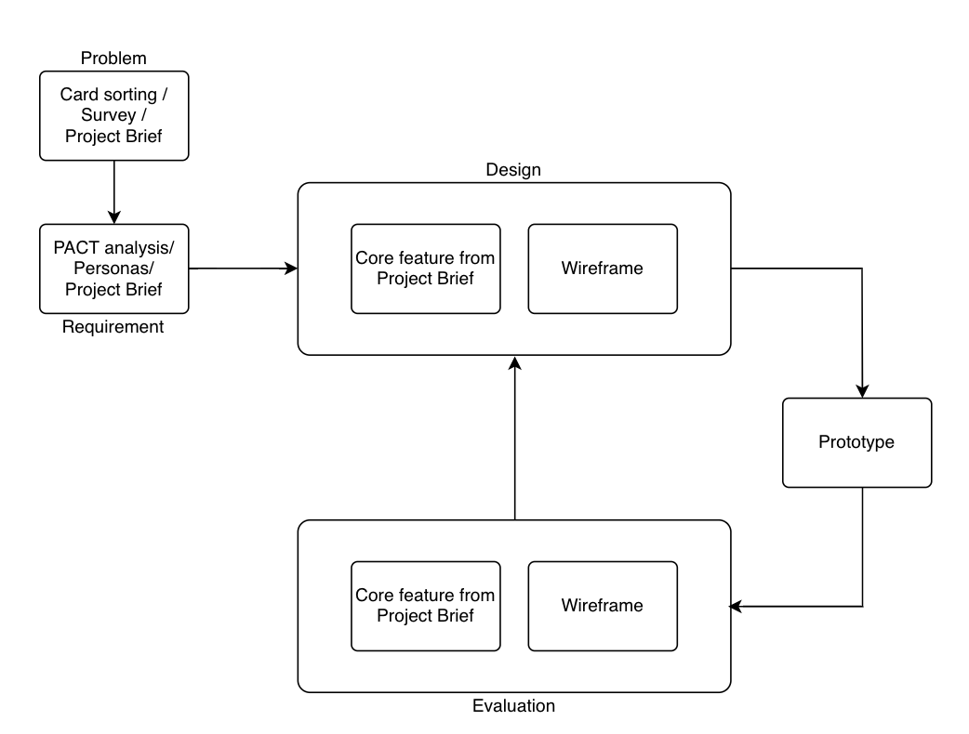

**Source codes:** **CSS for header**

li.a{

position:absolute;

left:5%;

top:3.3%;

text-align: left;

}

li.b{

position:absolute;

left:12%;

top:1.3%;

}

li.c{

position:absolute;

left:18%;

top:1.3%;

}

li.d{

position: absolute;

left:24%;

top:1.3%;

}

li.e{

position:absolute;

left:30%;

top:1.3%;

}

li.f{

position:absolute;

left:80%;

top:1.3%;

}

li.g{

position:absolute;

left:95%;

top:1.3%;

}

**Source codes:** **HTML for header**

<!DOCTYPE html>

<html>

<head>

<title>W4School - We teach web development</title>

<link rel="stylesheet" href="/css/header.css">

<link rel="stylesheet" href="/css/temp.css">

<script src="/js/script_head.js"></script>

</head>

<body>

<p>

<ul>

<li><a class="active" href="/home"><img src="/img/logo.svg" height="70" width="70"></img></a></li>

<li class="a"><a href="#">W4School</a></li>

<li class="b"><a href="/login"><img src="/img/course.svg" height="50" width="50" ></img></a></li>

<li class="c"><a href="/about"><img src="/img/forum.svg" height="50" width="50"></img></a></li>

<li class="d"><a href="#"><img src="/img/feeds.svg" height="50" width="50"></img></a></li>

<li class="e"><a href="#"><img src="/img/help.svg" height="50" width="50"></img></a></li>

<li class="f"><a href="#"><img src="/img/search.svg" height="50" width="50"></img></a></li>

<li class="g"><a href="#"><img src="/img/user.svg" height="50" width="50"></img></a></li>

</ul>

</p>

</body>

</html>

**Third reflection:**

For these two weeks, I completed some tasks for our project and finished the tutorial sheet on time. But during the process, I found tons of things needed to be improved. For week 3 tutorial, we mainly focus on the accessibility auditing. We review the WCAG2.1 and perform accessibility checking during the tutorial for tiktok.com. By using Lighthouse and Manual testing tools, I found that a good website cannot just shown well, but also needed to perform a good structure. The accessibility audit is a good way to check the sufficiency and to renew and improved the idea.

**April 16th, 2021 – WK6 Logbook**

**ACCOUNT REGISTRATION**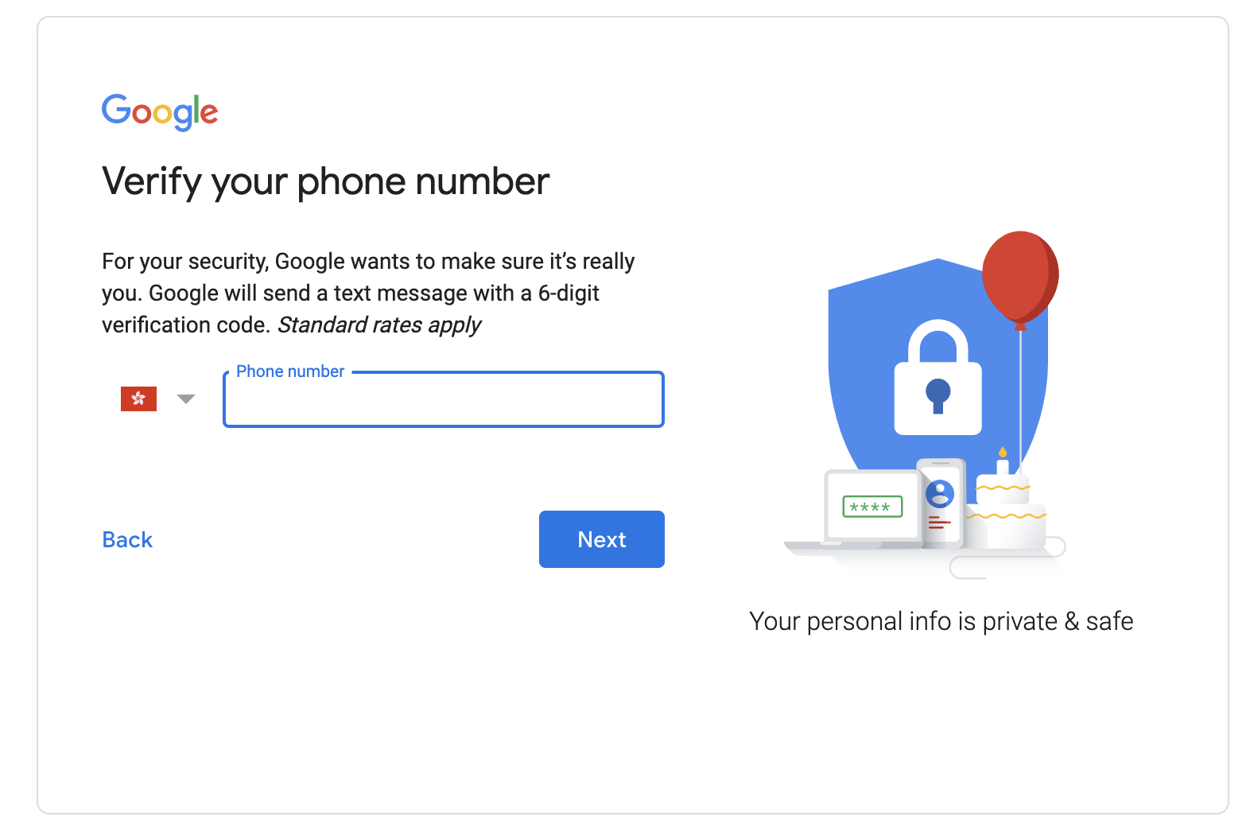

For this week, we firstly do our group demonstration in tutorial. Afterwards, we can pick one top website to do the account registration. I choose to sign up a new google account. At last, I did not register for an account successfully, because after I enter the first name, second name, the email, and the password. When I clicked that next button, it requires a phone number, but my phone number has already been signed up for google account, so I quitted.

According to the tutorial sheet’s question:

**a. Did you have difficulty locating the ‘Register’ button?**

It is easy to find the button.

**b. What type of information is requested for you to register for an account?**

The real name, email address and phone number.

**c. How many websites had password and/or username requirements?**

A lot of websites do.

**d. How many websites prompt you to set security questions or require two factor authentication?**

A lot of websites requires.

**e. How many websites prompt you to read their terms and conditions agreement during the registration process?**

All websites prompt that, but the minority of people will do.

**f. Did you read the contents of the agreement? If so, did it mention the type of information that is collected and how this will be used by the company?**

No.

**Report – Lifecyle of our progress** 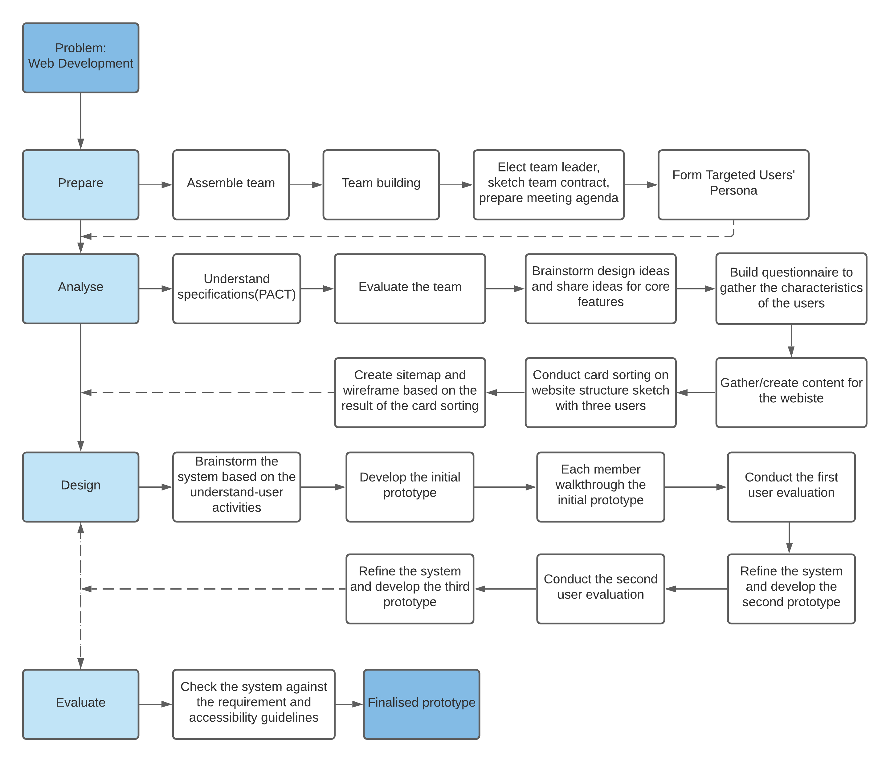

My part of report is to do the lifecyle of the project and manage the layout for whole project report.

**Forth reflection:**

For this week, I spent a tons of time to fix the prototype that we will use to do the demonstration. Because the user evaluation is continuous procedure, we did many iterative version for our project. Also I spent some time to do the report of our project, such as draw a graph of lifecycle and layout design. After I did the lifecycle, I suddenly found that it could be a preparation for project then keep tracking the lifecycle to do the project. But if it is as a artefact for the ending, it also can help me to know the whole process of our project, as I can know the problem when I do the project or something else. It could help me to improve my thinking way to do next coming project.